Date: February 9, 2024
Proposal: Warren County School System

Attn: Dr. Carrington
SUBJECT: Janitorial Supplies
Quantity | Description | Price | Amount
15 | 24/7 Cleaner | $100.00/PL | $1,500.00
 | 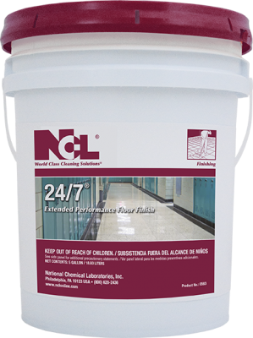
15 | Barebones | $90.00/PL | $1,350.00
 | 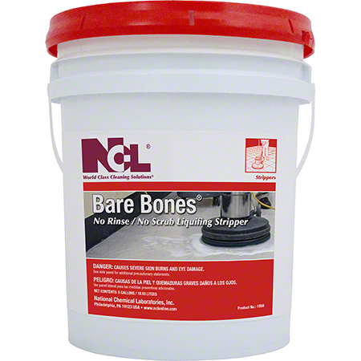
15 | Qwik-Scrub | $45.00/CS | $675.00
 | 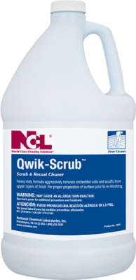
2 | FR20115-11 FRONT RUNNER 20" 115V, SINGLE SPEED | $1,180.00 | $2,360.00
 | 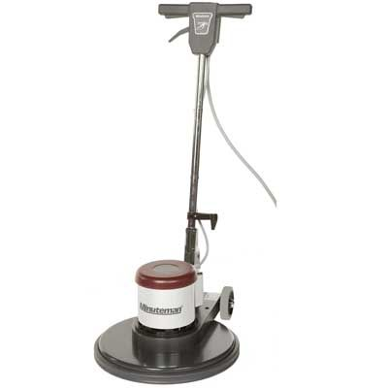
7 | E20BDQP WBS 12G 20" BD DISC | $4400.00/EA | $30,800
 | 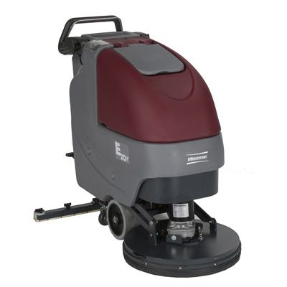
3 | X17115 X17 ECO EXTRACTOR 115VAC | $4,250.00 | $12,750.00
 | 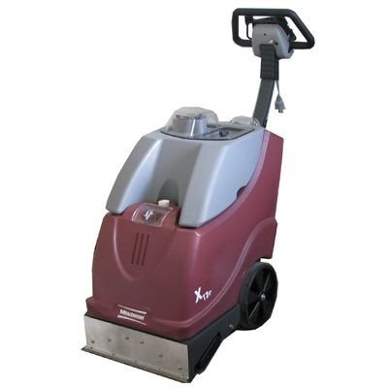
3 | TSUNAMI 16 Gal. WETVAC W/ SQUEEGEE ASSEMBLY | $1,085.00/EA | $3,255.00
 | 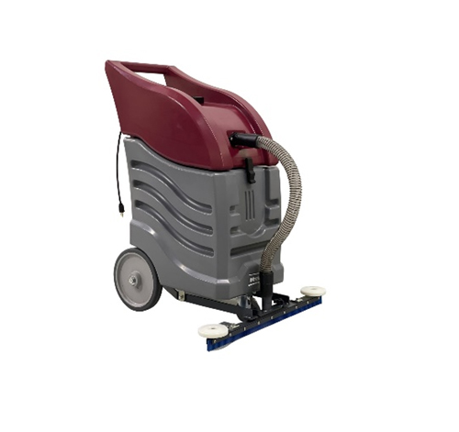
 | TOTAL |  | $52,690.00

Thanks for the opportunity to submit this quote.

